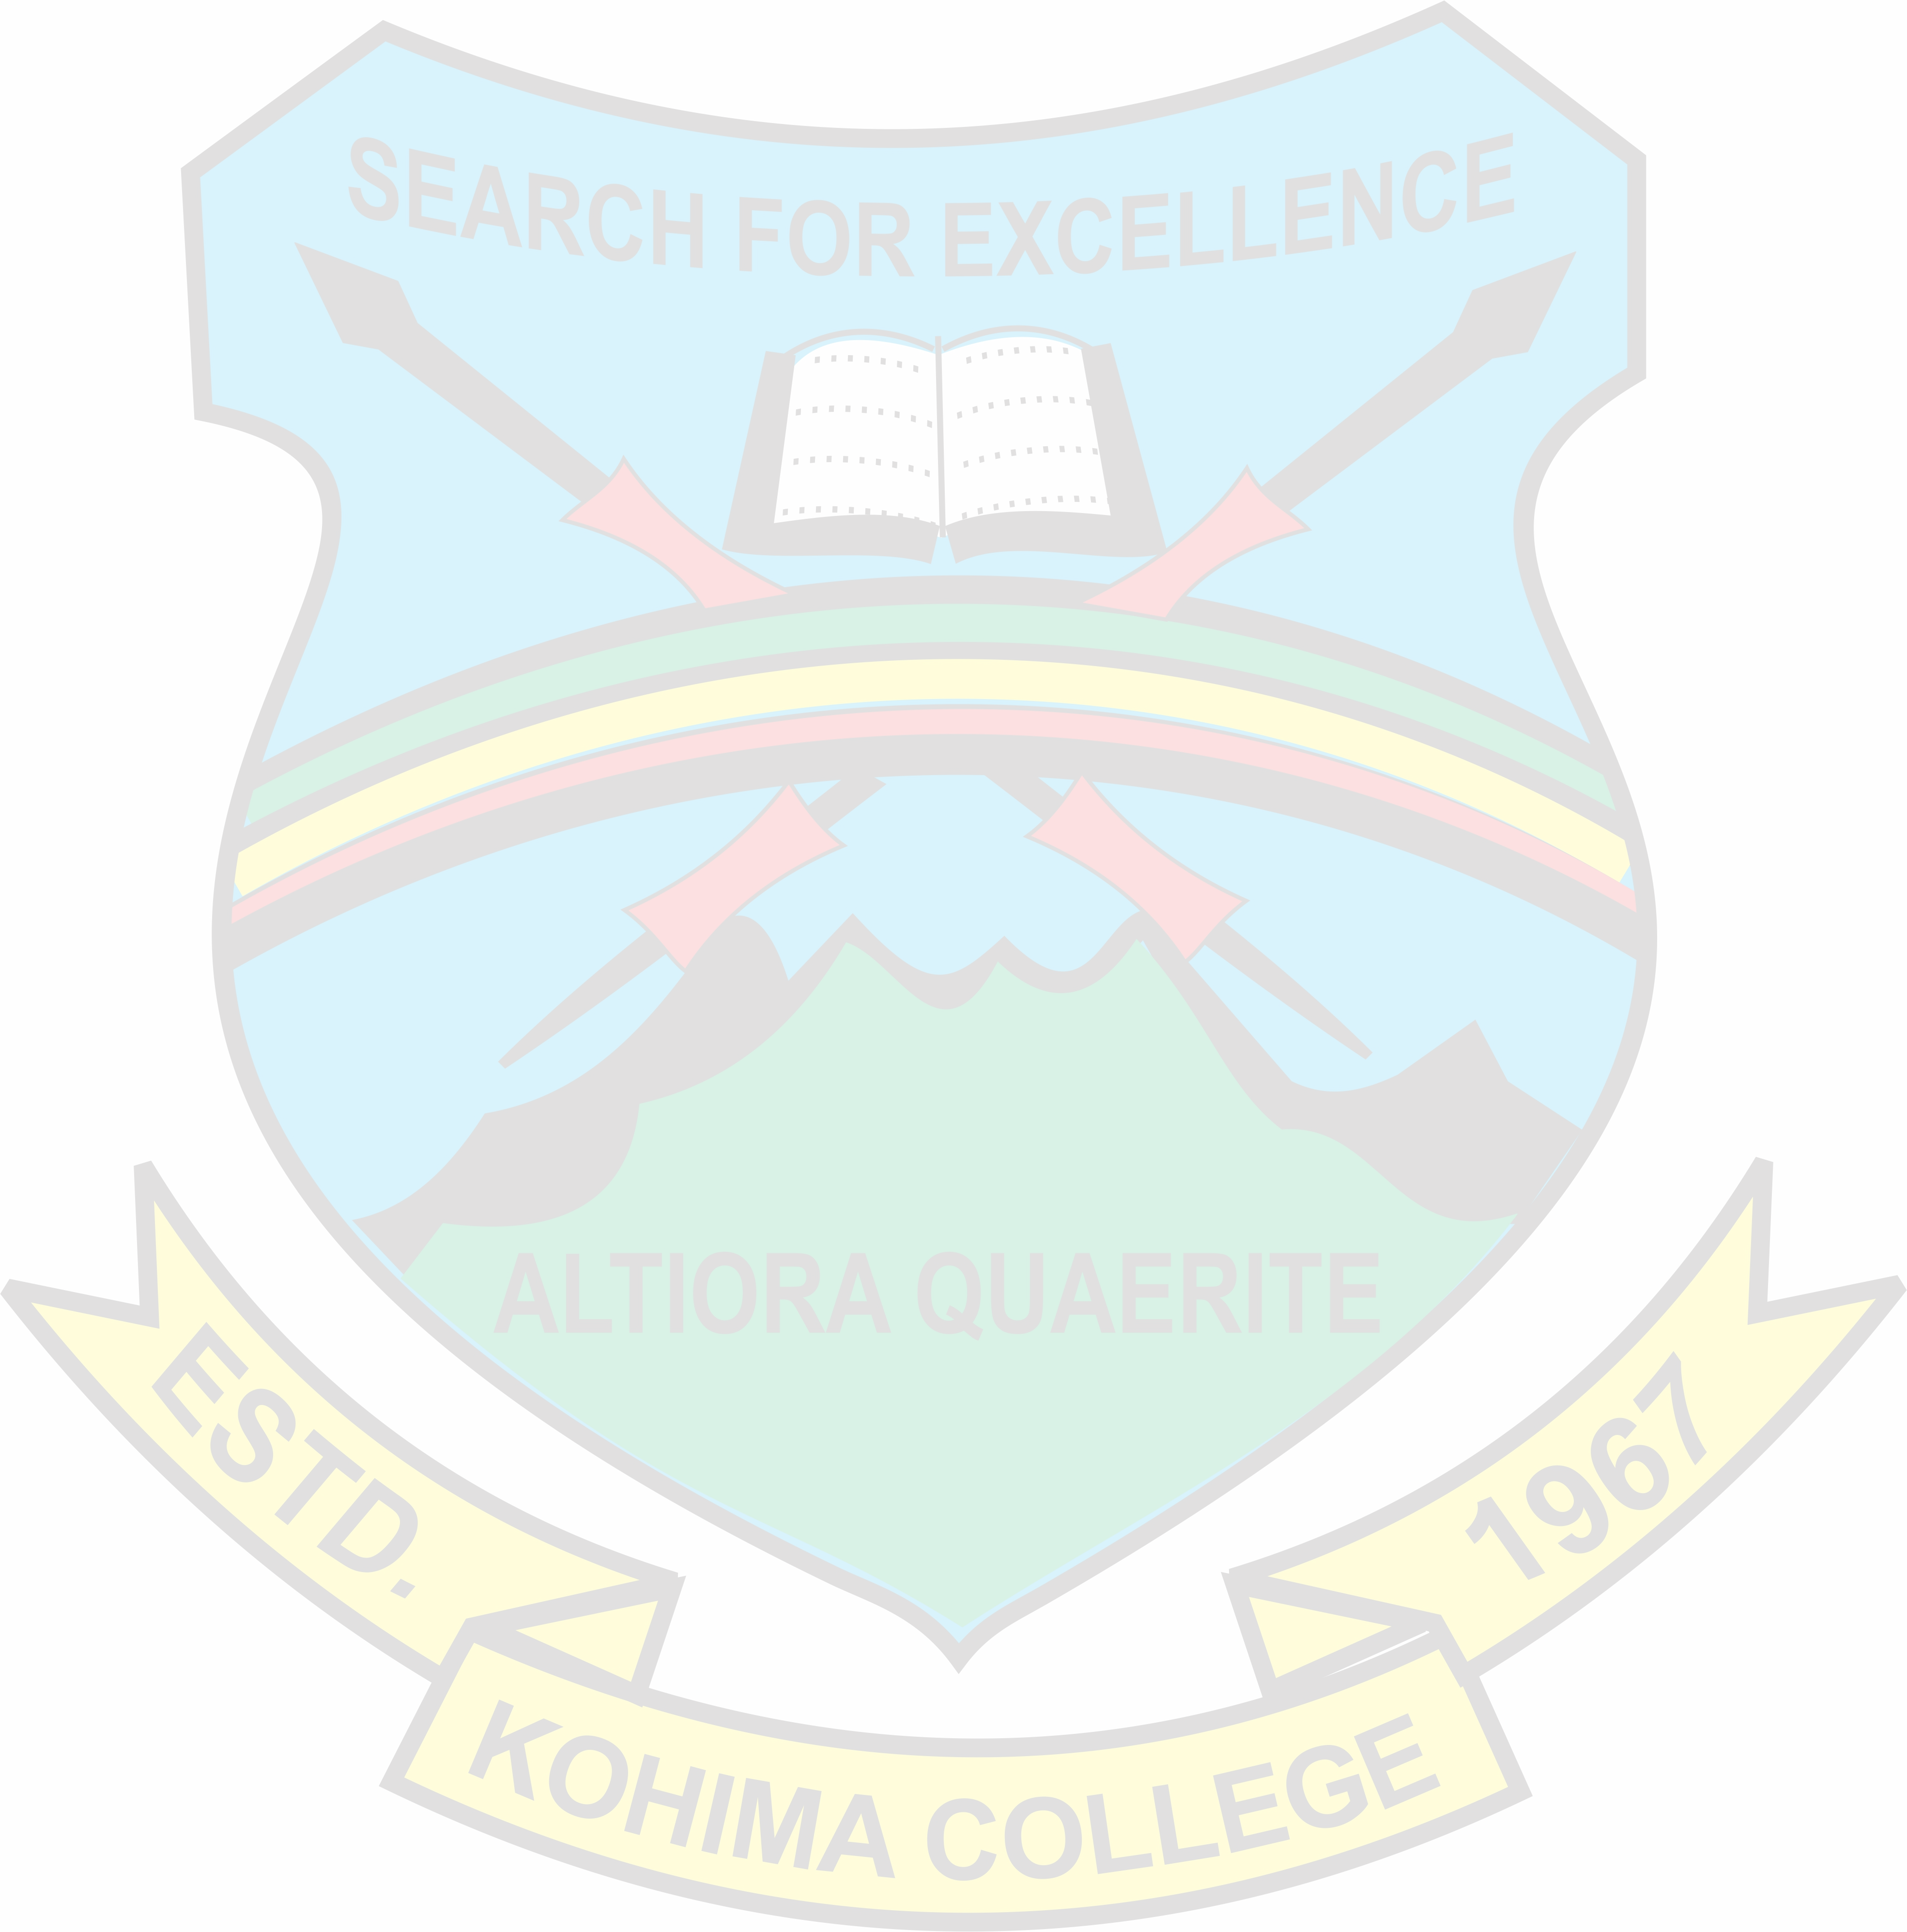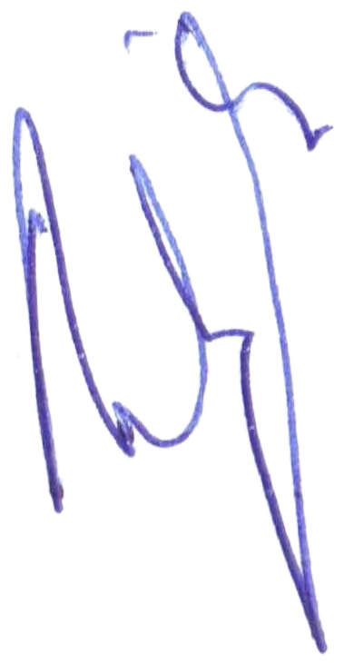GOVERNMENT OF NAGALAND
OFFICE OF THE PRINCIPAL, KOHIMA COLLEGE, KOHIMA KOHIMA: NAGALAND

NO.KCK/CIRCULAR/2020/ /Dated Kohima, the 16th July, 2021.

ADMISSION NOTIFICATION
(B.A. & B.COM. 1st Semesters)

This is for the information of all interested students seeking admission to B.A & B.Com 1st Semester at Kohima College that Online application forms submission and subsequent provisional admission to B.A. & B.Com. 1st Semester 2021 will be as stated below:

  - Issuance & Submission of Forms : 19th – 23rd July 2021.
  - Declaration of selected list: 30th July 2021.
  - Admission dates: 30th July – 3rd August 2021.
  - Commencement of Classes – 10th August 2021.

For all necessary instructions for admission, please refer to the latest instructions uploaded in the college website at https://www.kohimacollege.ac.in dated 16th July 2021.

PRINCIPAL
Kohima College, Kohima Kohima: Nagaland

